# Table of Contents

**Network-as-a-Service Runbook**

**RAN HLD Report Template**

**(Draft)**

**Facebook NaaS Runbook**



*March, 2020*

Table of Contents 1

Document Control 3

About Design Template 4

Document Purpose 4

Executive Summary 4

1. Introduction 5

2. Radio Configuration Description 5

Radio Configuration Summary 5

Standard Configuration 1 5

Standard Configuration 2 5

Standard Configuration “n” 5

3. RAN Solution Description 5

Annex I. Detailed RAN Solution 7

# Document Control

'- Revision Control sheet allows to maintain a record of changes made on the document.

|  |  |  |  |
| --- | --- | --- | --- |
| Version N° | Issue Date | Status | Reasons for Change |
|  |  |  |  |
|  |  |  |  |
|  |  |  |  |
|  |  |  |  |

Table 1. Revision History

# About Design Template

## Document Purpose

The purpose of this document is to outline the High-Level Design (HLD) Recommendations.

The document is split into following main sections:

* Radio Network Configuration Description
* Radio Network Solution Description
* Annexes

*Note: The above sections may change depending on the customer’s needs*

# Executive Summary

Brief summary of HLD Recommendation that management team can examine to rapidly become acquainted with HLD content without the necessity to read the complete document.

# 1. Introduction

Introduction to document, that should contain:

* Radio Configuration Description

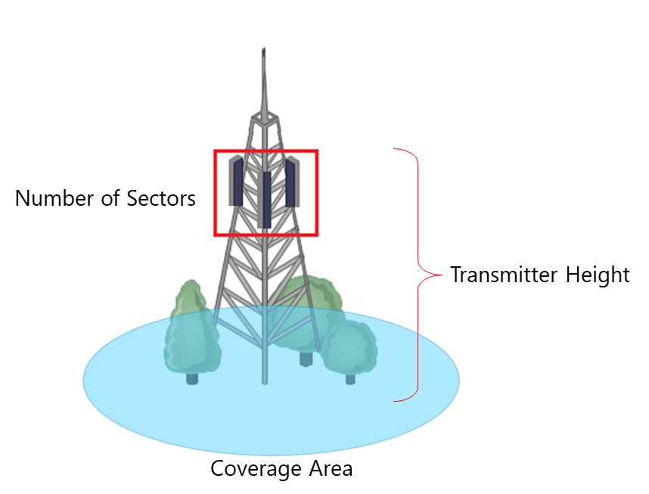

Figure 1.

* Service Level Description

# 2. Radio Network Configuration Description

Summary of the Radio Configuration for the sites integrating the network. A brief description of each standard configuration can be presented as well.

## Radio Configuration Summary



### Standard Configuration 1

### Standard Configuration 2

### Standard Configuration “n”

# 3. Radio Network Solution Description

High-level description of RAN solution. The content must include:

* Distribution of the radio sites in the desired covered area.

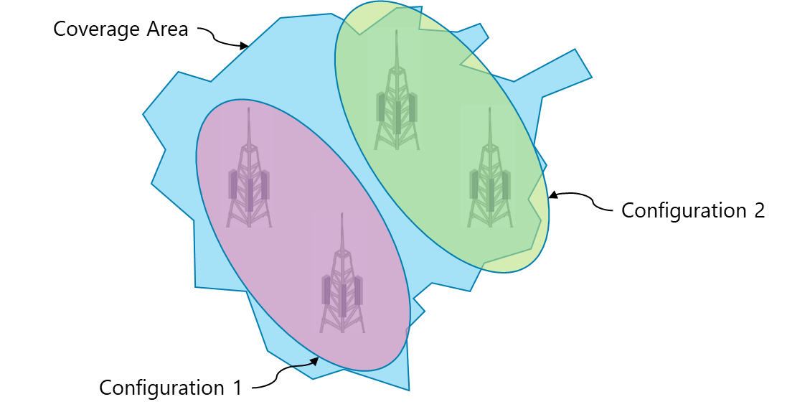

# Annex I. Detailed RAN Solution

In this section, a complete detail on RAN Solution and Bill of Quantities is provided. The RAN HLD Template can be used as a basis to generate.